không cần interrupt vì chỉ có 1 thiết bị kết nối với PC trong 1 thời điểm

ioctl(): set speed of serial port (baundrate)

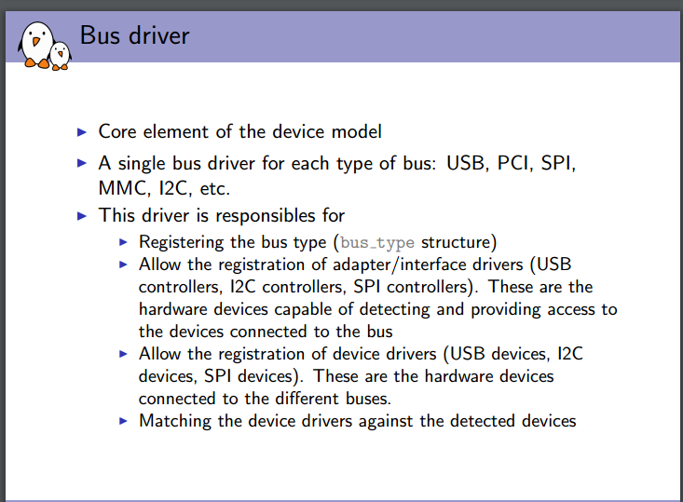

những struct có sẵn trong kernel

* usb_device
* usb_interface
* usb_endpoint_descriptor
* usb_cdc_line_coding
* us_cdc_parsed_header
* urb
* work_struct
* async_icount
* tty_driver
* tty_port
* tty_struct
* file
* serial_struct
* serial_icounter_struct

~~throttled, unthrottled ???~~

1. Look up an ACM structure by minor. If found and not disconected,

Increment

1. Find available minor number, if found, associate it with acm
2. Release the minor number associated with acm
3. ACM control messages ( **functions**)
4. Write buffer management
5. Finish write. Caller must hold **acm->write_lock**
6. poke write. The caller is responsible for locking
7. data interface wrote those outgoing bytes
8. TTY handlers (tty_**install, tty_open, port_activate, port_destruct,port_shutdown, tty_cleanup, tty_hangup, tty_close, tty_write,)**

Get_serial_info

Set_serial_info

Wait_serial_change

Acm_tty_**ioctl**

**Acm_tty_set_termios**

1. USB probe and disconnect routines

Write_buffers_free

Read_buffer_free

Wite_buffers_alloc

Acm_probe

….

Acm_disconnect

1. USB structure

Nokia blabla

1. TTY driver structures

.install

.open

.close

….

1. Init / exit

__init acm_init

__exit acm_exit

**Module_init(acm_init)**

**Module_exit(acm_exit)**